ACSL
American Computer Science League
2013 - 2014

Contest #4

Intermediate Division

1.
- Data Structures
How many nodes have only one child in the binary search tree for
DENVERBRONCOS

2.
- Data Structures
What would the next popped element be in the following queue?

PUSH(P), PUSH(I), PUSH(K), POP(X), POP(X), PUSH(E),
PUSH(S), PUSH(P), POP(X), POP(X), PUSH(E), POP(X), PUSH(A), PUSH(K)

3.
- Digital Electronics What ordered triple(s) make the following circuit FALSE?
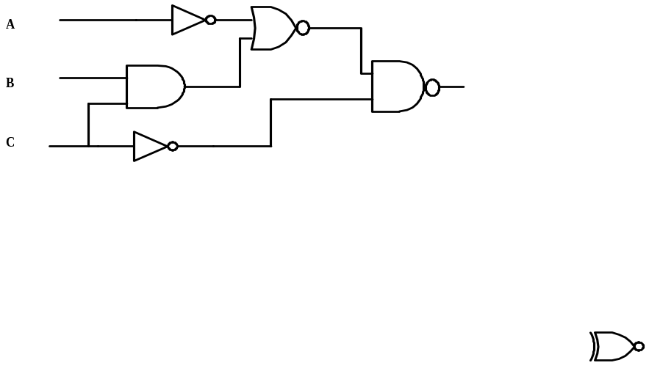

- Digital Electronics Simplify the Boolean expression represented by the
circuit below.
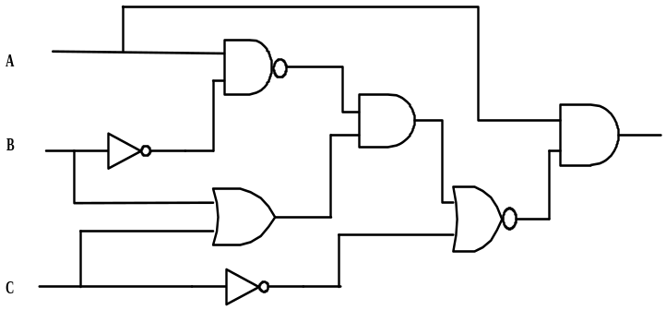
4.

5. LISP
Evaluate
(CAR (CDR (CDR ‘( 1 ( 2 ) ( 3 ( 4 ) ) ) ) ) )

5.

